Details of your portfolio
PD URL site (*Compulsory to fill up for milestone 2 and 3):
https://dylanxyz973.github.io/TheGradianttDaylan/

Name of your portfolio:
TheGradianttDaylan

Your Logo:
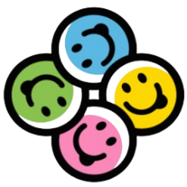
Banner (Tagline + twist name)
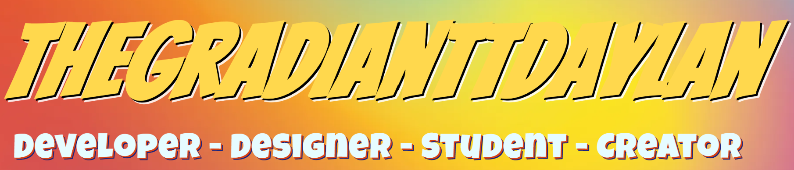

Describe your target audience:
My target audience would be potential employers in the front-end web development workplace. They should be looking out for skills related to web design and development. They typically are based in Singapore or can be from other English-speaking regions. They will possess a higher education level (diploma, degree, or any other relevant qualifications) typically in IT field or other certificates that are relevant to IT. They should have background knowledge in understanding how websites operate. They shall possess values attention to detail, technical expertise, and the ability to adapt to current trends. Usually, their beliefs would be that a good design creates productivity while being easy to maintain and they strive to achieve efficiency in development.

Describe your brand story/ purpose:
I am a student who specialises in digital design and development and I aspire to be a front-end web developer that can contribute to development of practical, innovative and visually pleasing websites that meet users’ needs and requirements.
My purpose is to show employers I can merge design and development to create works that stand out and deliver value by ensuring every project done utilises practical skills and that necessary requirements are achieved.

Design brief
Colour scheme & Colour palette:
I have decided to blend warm colour palette and cool colour palette combining it to form a gradient colour scheme. This help elevates the liveliness for the webpage and give my website a lot more personality and originality. Each page will have its own blend of gradient background which makes the website feel a lot more interesting.

Typography:
All fonts are imported from google fonts
Nunito
[Home page]
Hero Banner:
- H1 (Bangers)
- H2 (Luckiest Guy)
Theme:
Overall, my website theme is designed to be a modern artistic portfolio.

Layout/ Arrangement:
Figma Link:
https://www.figma.com/design/AMWmyPFsUh76dhv1260idk/C390?node-id=0-1&p=f&t=G6YE2MdSOZgzkms3-0

Image:
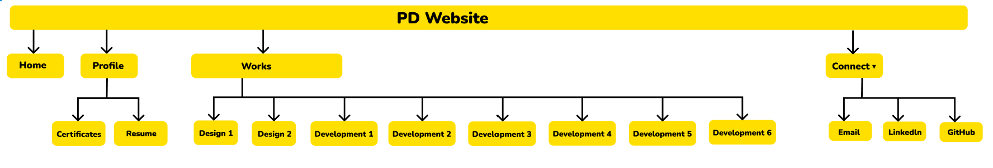

High fidelity wireframe (*Compulsory to fill up for milestone 2 and 3) (Done to best ability):
View Images below:

Home Page
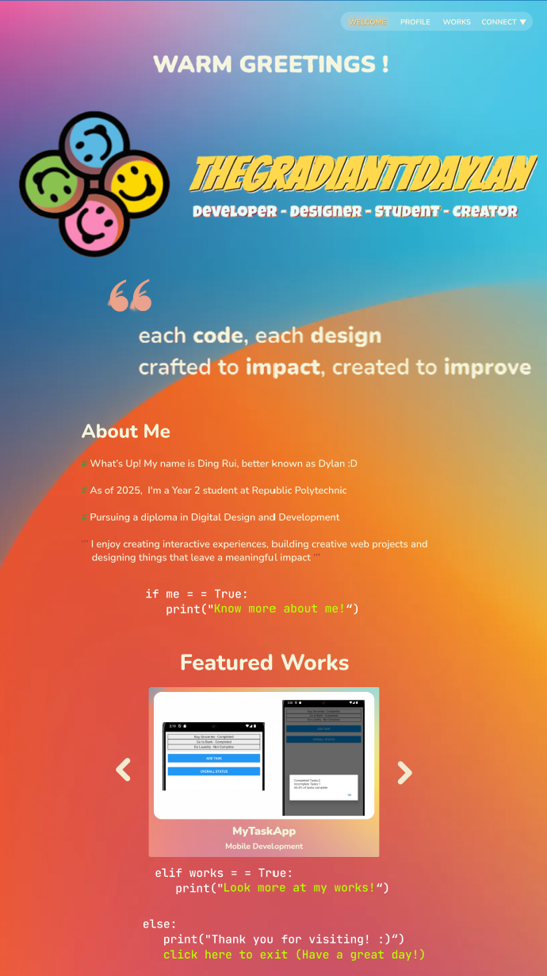

Certificate Page
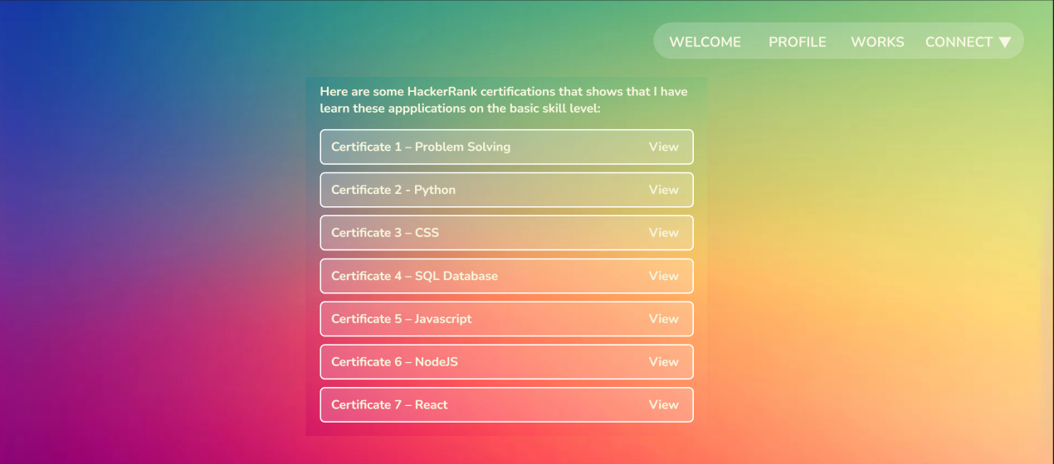

Work Page (Portfolio)
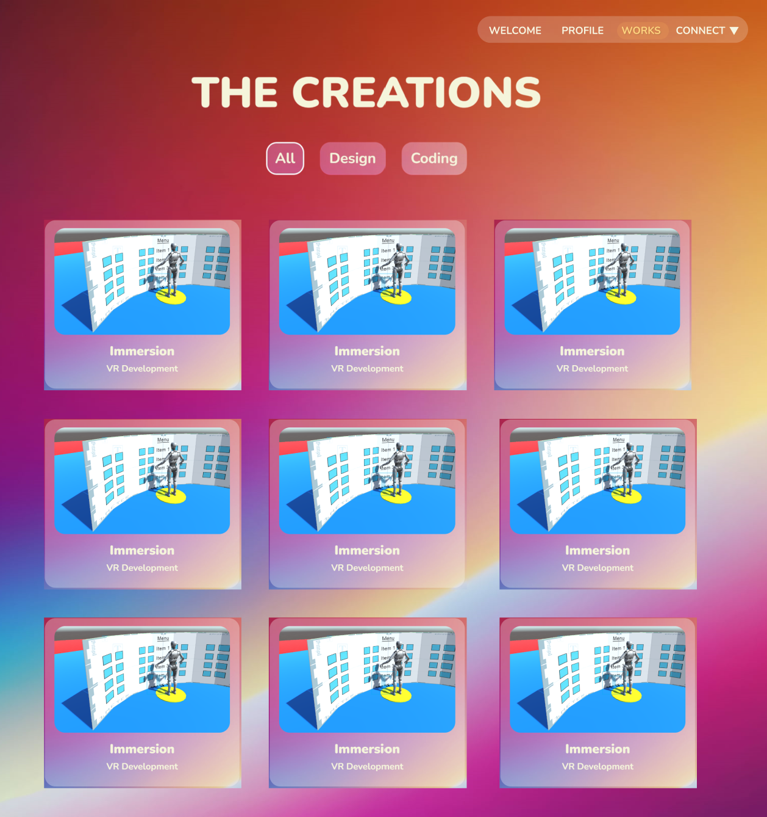

Work Page (Write-Up)
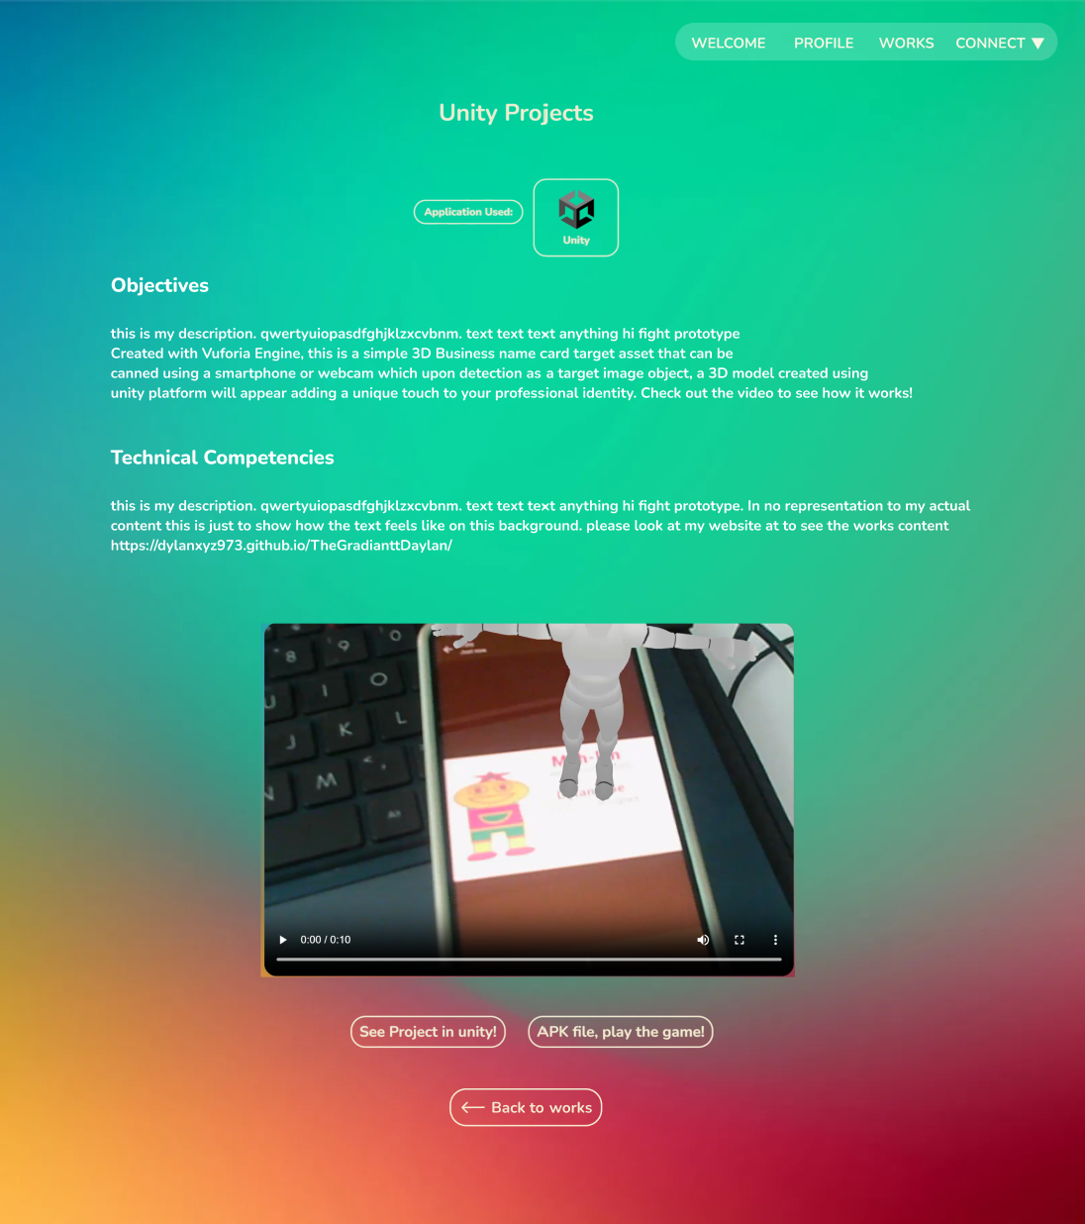

Link to your Prototype – Most likely on Figma (make sure your lecturer is given access to the site) (To fill up for milestone 2 and 3) (Done to best ability):
https://www.figma.com/design/AMWmyPFsUh76dhv1260idk/C390?node-id=2-2&t=1WdF7arK1r9XzPmC-1
Prototype have hover and interactions for only important elements. (Placed in component frames)
Details are listed below:
- Navbar and Green link text can hover and navigate to other pages.
- Work Page images can be clicked

Reference sites (*Optional):
https://docs.google.com/spreadsheets/d/10QoCC0RZwQWDhl6FpnaSRzswBuOEWHAU/edit?gid=1247136888#gid=1247136888
https://docs.google.com/spreadsheets/d/1XSYn1UK4G5DPmGiPrvWPeFl_whiwY0nM/edit?gid=1247136888#gid=1247136888
Seniors PD works
Google images, AI prompting

